SPA Application

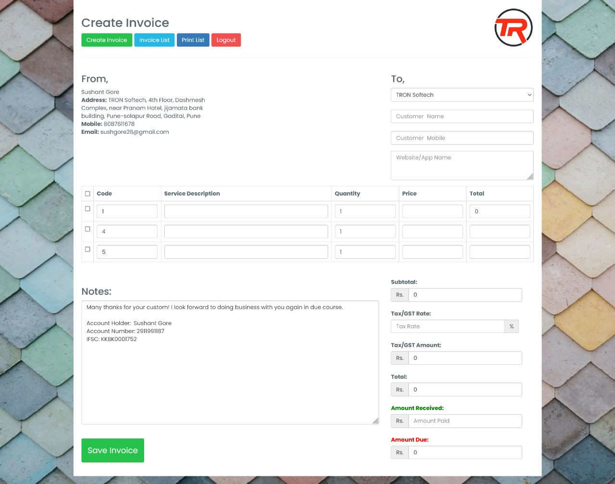

Screen 01 – Log In

Screen 02 – Create Invoice

Screen 03 – Invoice List

02 – Create Invoice

From To

Fetch Data from Manually Enter Data

Setting Master

Table

Code Service Description quantity price total

Notes : Manually Enter Notes

SubTotal – total price of added product

Tax/GST rate – manually enter Percentage of Tax

Tax/gst Ammount – calculate amount on subtotal price

Total = subtotal + gst amount

Amount received = manually enter amount

Amount due = Total – Amount received